

Executive Summary

This study analyzes IMDb movie data to identify factors influencing audience ratings. Results show that variables such as genre and duration have minimal impact, while popularity has a limited positive relationship with ratings. Differences between critic and audience scores highlight the subjective nature of evaluation. Overall, movie success is influenced more by qualitative factors than measurable attributes.

Table of Contents
Exploring Movie Ratings: An IMDb Data Analysis 1
Executive Summary 2
Table of Contents 3
Table of Figures 3
Introduction 4
Dataset Overview 5
Methodology 6
Analysis 7
Which genres have the highest average IMDb rating? 7
Are longer movies rated higher? 9
Is there a link between the number of votes and the rating? 11
Which 10 directors have high and low movie ratings with at least 2-3 movies? 12
IMDb Rating vs Meta Score 15
Key Insights 16

Table of Figures

Figure 1 | Average Rating per Genre | 7
Figure 2 | Count per Genre | 8
Figure 3 | IMDb Rating vs Duration | 10
Figure 4 | IMDb Rating vs Votes | 11
Figure 5 | Top 10 Directors with high movie ratings | 13
Figure 6 | Bottom 10 Directors with lower average ratings | 13
Figure 7 | Meta Score vs IMDb Rating | 15

Introduction

Movies are often evaluated based on both audience perception and critical review. Platforms such as IMDb and Metacritic provide quantitative ratings that reflect these perspectives, making them useful for analyzing patterns in movie success.
This project explores the factors that may influence movie ratings by examining relationships between genre, movie duration, popularity (number of votes), director performance, and critic scores (Metascore). The goal is to identify whether any of these variables have a significant impact on IMDb ratings and to understand how audience and critic evaluations compare.
The dataset includes movie-related attributes such as title, genre, duration, IMDb rating, Metascore, number of votes, and directors. These variables allow for a multi-angle analysis of how different factors may relate to perceived movie quality.
To analyze the data, exploratory data analysis (EDA) techniques were used, including pivot tables for aggregation and scatter plots with trendlines to examine relationships between numerical variables. The strength of relationships was evaluated using R² values.

Dataset Overview

The dataset used in this project was sourced from IMDb movie data that was web-scraped and uploaded to Kaggle. It contains information on the top 1,000 IMDb-rated movies, covering various attributes such as movie titles, genres, ratings, directors, cast members, and financial performance.
This dataset is a curated collection of highly rated and popular films, making it suitable for analyzing patterns in movie ratings and audience preferences.

The dataset includes 1,000 rows and 11 columns with the following variables:

- Movie Name – Title of the movie
- Certificate – Age or content rating assigned to the movie
- Duration – Runtime of the movie in minutes
- Genre – One or more genres associated with the movie
- IMDb Rating – Audience-based rating from IMDb
- Metascore – Critic-based score from Metacritic
- Director – Film director
- Stars – Main cast members
- Votes – Number of user ratings received
- Grossed in $ – Estimated box office earnings (if available)
- Plot – Summary of the movie

This dataset provides a strong foundation for exploratory data analysis, as it includes both numerical and categorical variables that allow for multiple types of comparisons and relationships.

Methodology

The analysis was conducted using spreadsheet-based tools to perform exploratory data analysis (EDA) on the dataset. The process focused on identifying patterns and relationships between movie attributes and IMDb ratings through data preparation, aggregation, and visualization.
Data preparation involved cleaning and transforming the dataset to ensure accuracy in analysis, including handling multi-genre entries and extracting relevant numerical values for comparison. This step ensured that the data was properly structured for analysis.

Several analytical techniques were then applied:

- Data cleaning and transformation – preparing and restructuring data for analysis
- Pivot tables – used to aggregate and summarize data such as average ratings by genre and director
- Scatter plots with trendlines – used to visualize relationships between numerical variables such as duration, votes, and ratings
- R² (coefficient of determination) – used to measure the strength of relationships between variables
- Charts and visualizations – used to support interpretation and identify patterns in the data

These methods were used to examine relationships between variables and support data-driven insights through visual and statistical interpretation.

Analysis

Which genres have the highest average IMDb rating?

Objective
To identify which movie genres have the highest average IMDb ratings and determine whether genre influences audience perception.

Method
- Flattened multi-genre entries to ensure each genre is counted correctly
- Used pivot tables to compute average IMDb ratings per genre
- Generated charts to visualize average ratings and genre frequency

Multi-genre movies influence every genre they belong to, which is exactly what we want for genre analysis.
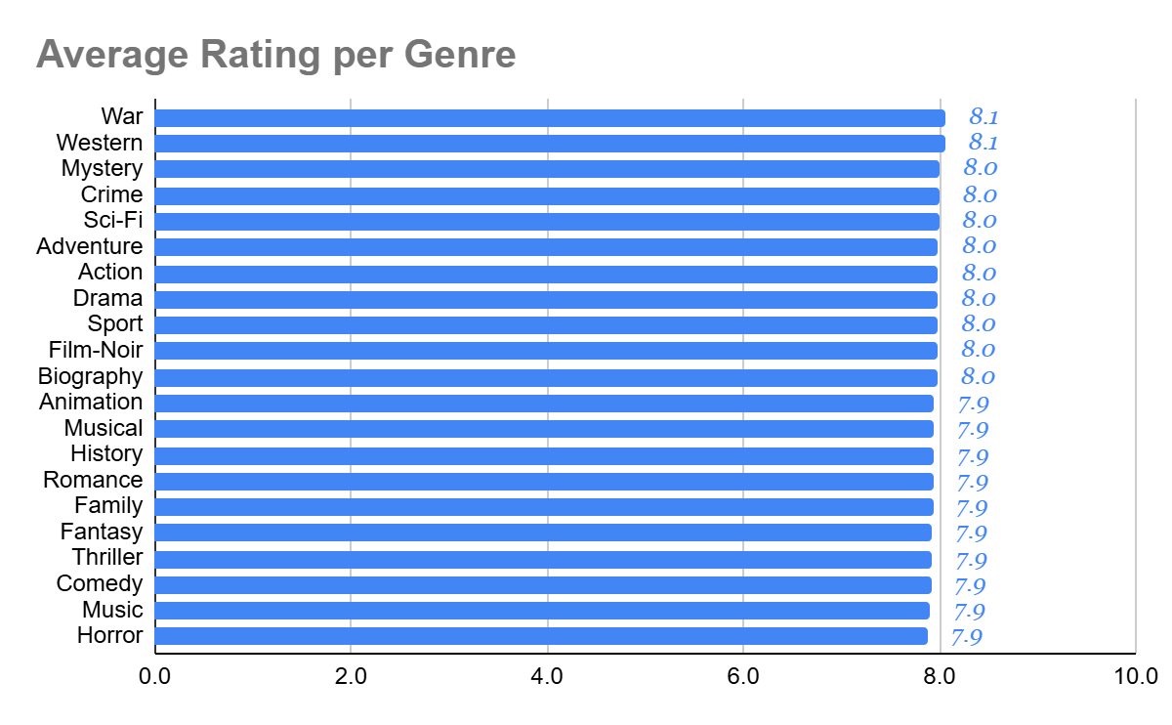

Figure 1. Average Rating per Genre

Findings
Most genres have similar average IMDb ratings, ranging from 7.9 to 8.1, with War and Western genres showing slightly higher averages at 8.1. This minimal variation suggests that viewers do not strongly favor one genre over another in terms of ratings.

Explanation
One possible reason is that IMDb ratings reflect overall audience satisfaction, which depends more on storytelling, direction, and execution rather than genre alone. High-quality films can emerge from any genre, leading to similar average ratings.

Implication
Genre may not be a reliable predictor of a movie’s success. For analysts, producers, or viewers, this suggests that focusing on quality factors (e.g., narrative, production) is more important than relying on genre trends alone.

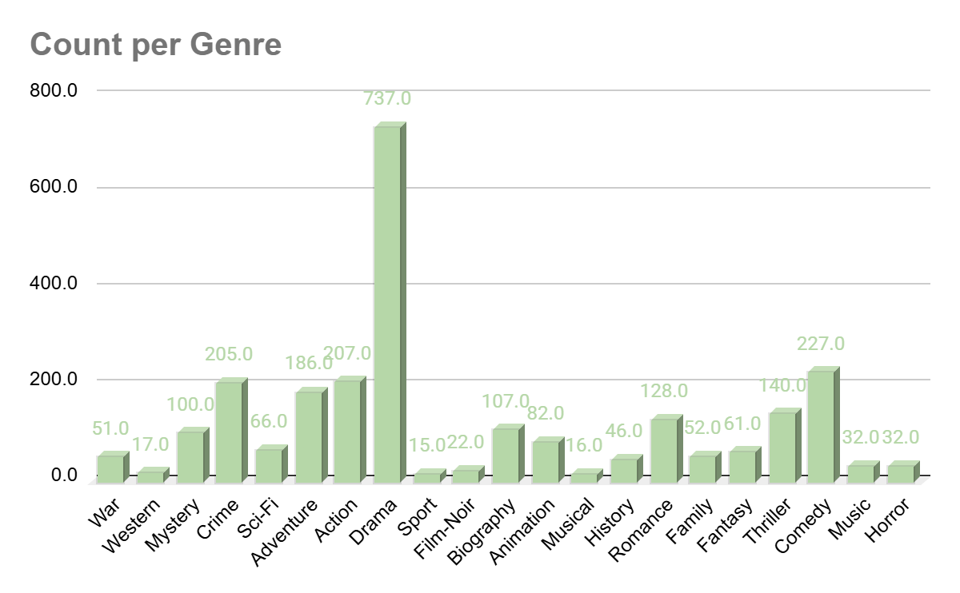

Figure 2. Count per Genre

Findings
The Drama genre has the highest number of movies (737), making it the most represented genre in the dataset. However, despite its large volume, it does not have the highest average rating.

Explanation
This may be because Drama is a broad and flexible genre that includes a wide range of films, from highly acclaimed to average ones, which can lower its overall average rating.

Implication
A higher number of movies in a genre does not guarantee higher quality. In fact, more volume may introduce greater variability, making average ratings less indicative of consistent excellence.

Overall, genre does not appear to be a strong determinant of IMDb ratings, as most genres receive similar average scores despite differences in representation.

Are longer movies rated higher?

Objective
To examine the relationship between movie duration and IMDb ratings and determine whether longer movies receive higher ratings.

Method
- Separate the needed data, such as Movie name, duration, and IMDb Rating.
- Split the duration to remove the minutes from the original data set
- Insert a scatter chart with a trendline

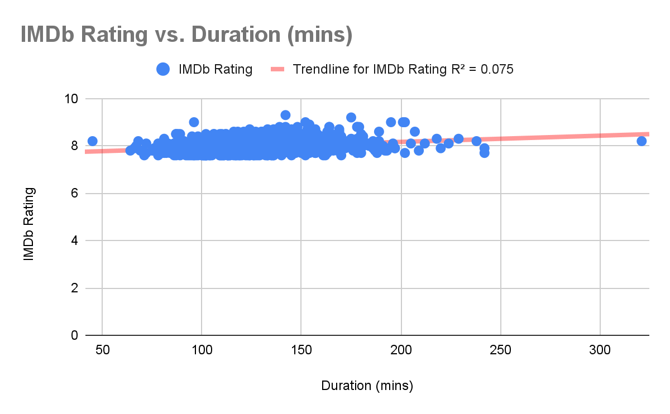

Figure 3. IMDb Rating vs Duration

Findings
The scatter plot shows a weak relationship between movie duration and IMDb rating, supported by a low R² value of 0.075. This indicates that only a small portion of the variation in ratings can be explained by duration.
Additionally, ratings remain within a narrow range across both short and long movies, suggesting that movie length does not significantly influence audience ratings. Notably, both shorter and longer movies can receive similar ratings, reinforcing the idea that duration is not a key factor in determining a movie’s success.

Explanation
This may be because viewers prioritize story quality and engagement rather than runtime. A longer movie does not necessarily mean better storytelling, and shorter films can be just as impactful.

Implication
Movie duration is not a strong factor in determining success. For filmmakers, this suggests that optimizing runtime should focus on storytelling needs rather than assuming longer films will perform better.
Overall, duration is not a reliable predictor of movie ratings.

Is there a link between the number of votes and the rating?

Objective
To examine whether the number of votes is associated with IMDb ratings. Observe how the number of votes affects the rating of the movie.

Method
- Separate the needed data, such as Movie name, votes, and IMDb Rating.
- Sort the data in descending order
- Insert a scatter chart with a trendline
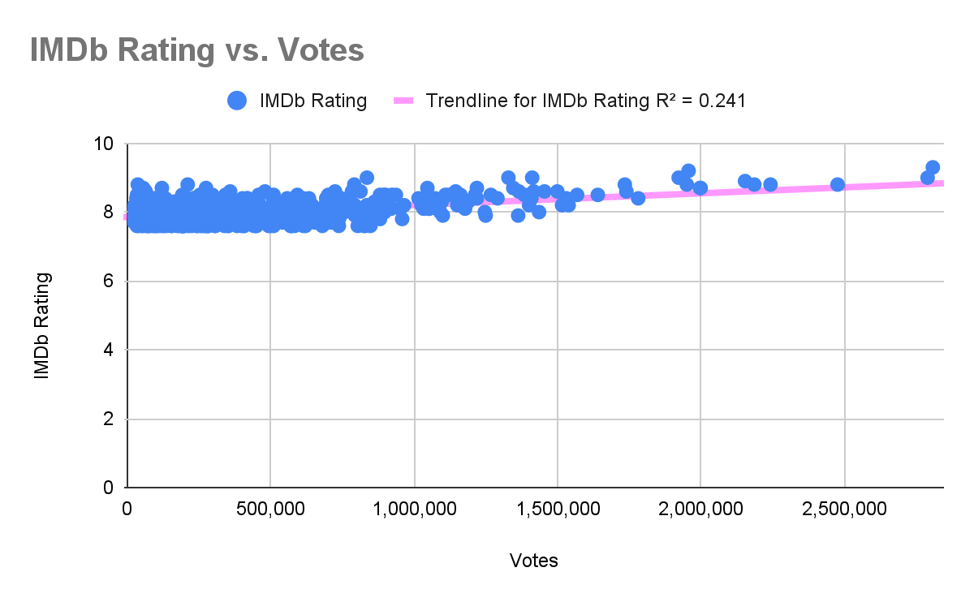

Figure 4. IMDb Rating vs Votes

Findings
The scatter plot shows a weak to moderate positive relationship between the number of votes and IMDb rating, supported by an R² value of 0.241. While most movies cluster at lower vote counts with a wide range of ratings, films with higher numbers of votes tend to have slightly higher ratings.
However, the relationship is not strong, indicating that while popularity may have some influence, it is not the sole factor affecting movie ratings. Notably, a small number of movies with very high vote counts also have high ratings, suggesting that widely viewed films may achieve strong audience approval, though this is not consistent across all data points.

Explanation
One explanation is that widely viewed movies are more likely to be well-received or widely discussed, leading to both higher visibility and stronger consensus among viewers. Additionally, highly rated films may attract more viewers over time, increasing their vote count.

Implication
Popularity and quality may reinforce each other, but the relationship is not strong. High visibility does not always guarantee high ratings, so both metrics should be considered separately when evaluating a movie’s success.

Overall, popularity may influence ratings slightly, but it is not a definitive factor.

Which 10 directors have high and low movie ratings with at least 2-3 movies?

Objective
To identify the top and bottom 10 directors based on average IMDb ratings, considering only those with at least three films to ensure fair comparison.

Method
- Use a pivot table to select directors, genre, average rating, and the number of movies they made.
- Add Director and Genre with the show total for the row.
- Add IMDb rating with a summary by average, and the movie name with count.
- Filter data using the total average and the count of movies greater than three (3).
- Collect the top 10 and bottom 10 directors and use a chart to visualize the two data sets.
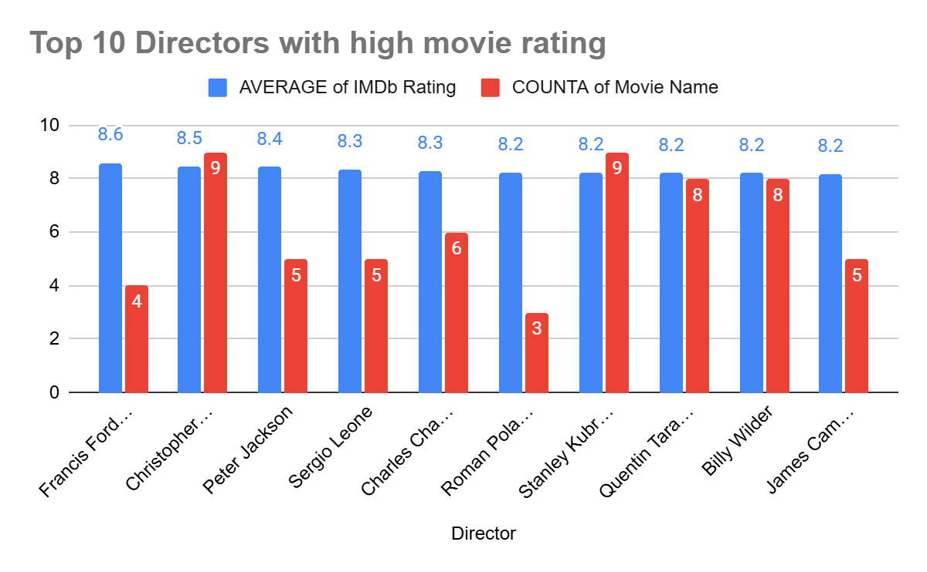

Figure 5. Top 10 Directors with high movie ratings
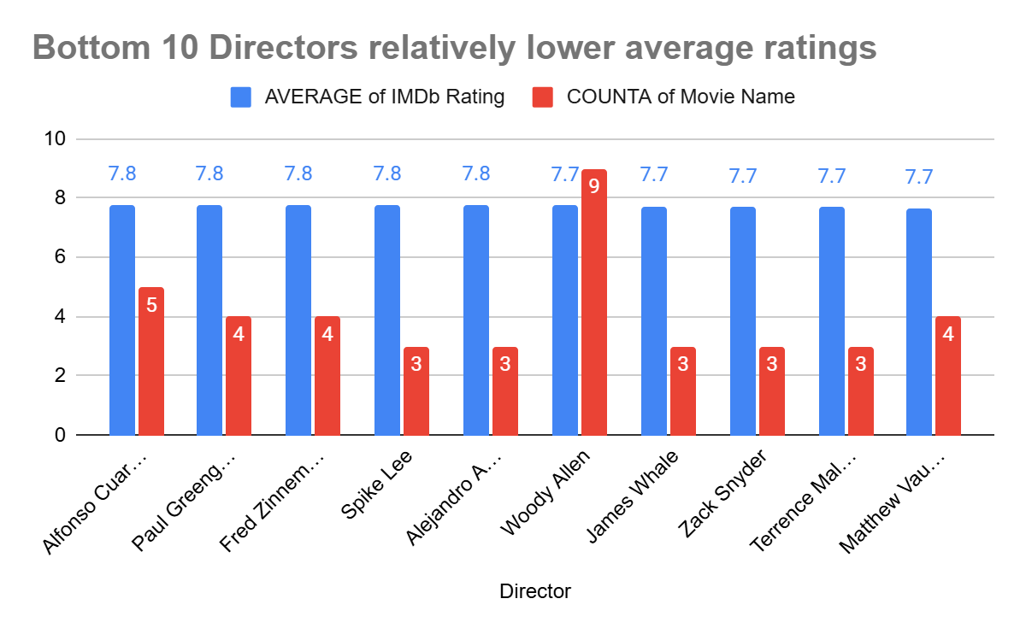

Figure 6. Bottom 10 Directors with lower average ratings

Findings
The analysis compares the top and bottom 10 directors based on average IMDb ratings, considering only those with at least three films. Directors such as Francis Ford Coppola and Christopher Nolan achieve the highest averages, while the difference between the top and bottom groups remains relatively small.
Even the lowest-ranked directors maintain ratings above 7.7, indicating that the dataset consists primarily of well-received films.

Explanation
This may be because the dataset is composed mainly of popular or critically recognized films, which tend to receive higher ratings. Additionally, experienced directors often develop consistent storytelling styles that contribute to stable audience reception across their work.

Implication
While some directors consistently achieve higher ratings, the overall variation is limited, suggesting that most directors in the dataset produce generally well-received films. This also indicates a potential bias toward higher-quality movies within the dataset.

Overall, differences in director performance exist, but they are relatively small due to the consistently high quality of films in the dataset.

IMDb Rating vs Meta Score

Objective
To examine the relationship between IMDb ratings and Metascores and determine whether audience and critic evaluations are aligned.

Method
- Separate the needed data, such as Movie name, Meta Score, and IMDb Rating.
- Insert a scatter chart with a trendline
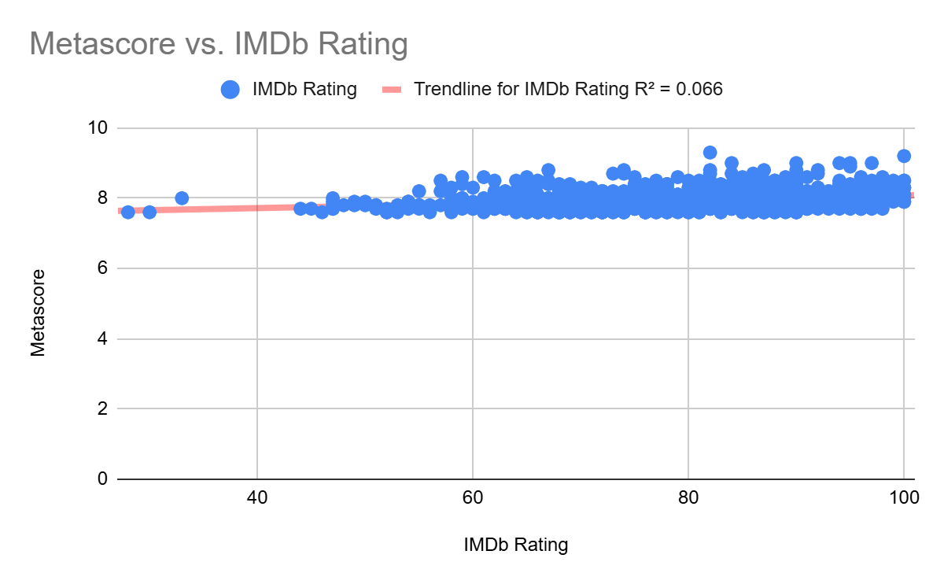

Figure 7. Meta Score vs IMDb Rating
Findings
The scatter plot shows a weak relationship between IMDb ratings and Metascores, supported by a low R² value of 0.066. Most movies cluster within a wide range of Metascores (approximately 44 to 100) while maintaining relatively similar IMDb ratings, indicating limited alignment between critic and audience scores.

Explanation
This may be because critics and general audiences evaluate movies using different criteria. Critics often focus on technical elements such as cinematography, narrative structure, and artistic value, while audiences tend to prioritize entertainment, emotional impact, and overall enjoyment.

Notably, some films such as The Godfather and 12 Angry Men receive both high critic and audience ratings, demonstrating that strong agreement can occur for exceptional films.

Implication
IMDb ratings and Metascores should not be used interchangeably. For viewers seeking reliable recommendations, considering both critic and audience perspectives provides a more balanced evaluation of a film’s quality.

Overall, critic and audience ratings capture different aspects of movie quality, and both are important for a comprehensive evaluation.

Key Insights
Overall, the analysis shows that movie ratings are not strongly influenced by individual measurable attributes such as genre or duration. Instead, audience perception appears to depend more on qualitative factors such as storytelling, direction, and overall engagement.
While popularity (measured by the number of votes) shows a slight relationship with ratings, it is not a definitive predictor of a movie’s success. Similarly, although some directors achieve higher average ratings, the variation between top and bottom performers remains relatively small, suggesting generally consistent quality across the dataset.
Additionally, the weak relationship between IMDb ratings and Metascores highlights the subjective nature of film evaluation, where critics and audiences often use different criteria. Considering both perspectives provides a more balanced and reliable basis for movie recommendations.

Limitations

The dataset consists primarily of highly rated and popular films, which limits variability and may reduce the strength of observable relationships between variables. This introduces a potential bias toward higher-quality movies, making it more difficult to detect stronger contrasts in ratings.

Additionally, several important factors were not included in the dataset, such as production budget, marketing efforts, release timing, and audience demographics. These variables may also significantly influence movie ratings and overall reception.

Conclusion

This analysis demonstrates that while certain patterns exist in movie ratings, no single measurable factor strongly determines a movie’s success. Instead, ratings are shaped by a combination of subjective and qualitative elements, reflecting the complexity of audience preferences.
Overall, the findings emphasize that movie success cannot be fully explained through isolated variables, highlighting the importance of considering both data-driven insights and human perception in evaluating films.

